EXPERIMENT NO 2

REDESIGN OF CANTEEN MENU

AIM: TO REDESIGN THE CANTEEN MENU IN DIFFERENT STYLE

PROCEDURE \*CREATE A WIREFRAME ACCORDING TO YOUR DESIGN.

\*SELECT THE FRAMEWORK FOR YOUR DESIGN.

\*CREATE DESIGN AND ADD ICONS,IMAGES NEEDED F0R YOUR DESIGN.

\*PROTOTYPE THE DESIGN

\*SAVE THE COMPLETED PROTOTYPE DESIGN

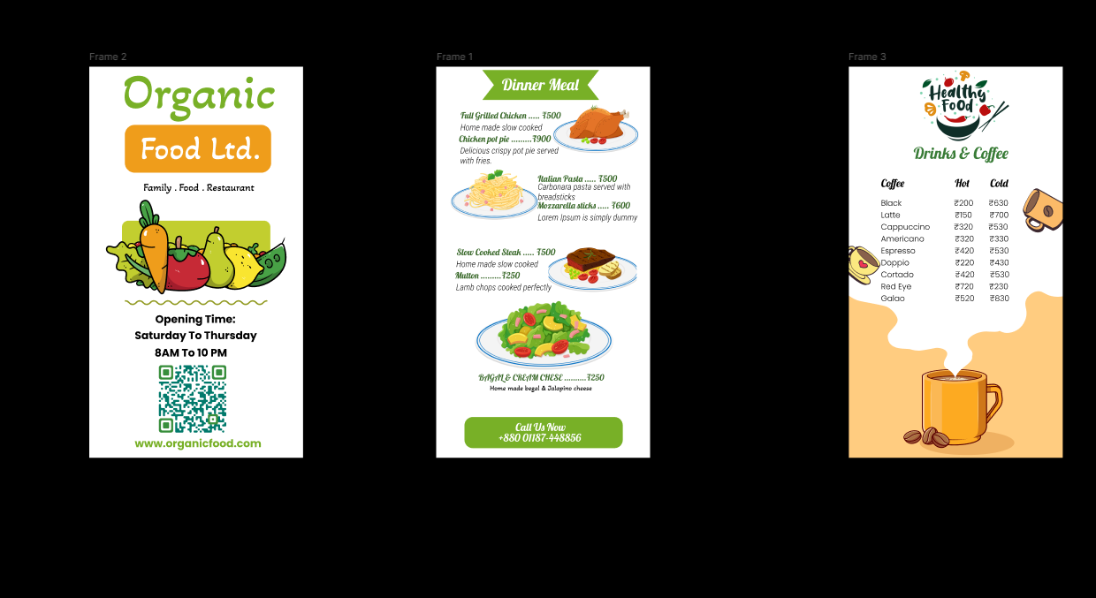

RESULT:

THE DESIGN WAS SUCESSFULLY CREATED